FOR T.D.C PART- I (GEOGRAPHY (Hon’s)
Paper – 1st (Physical Geography)
BY
Dr. ALPNA JYOTI
Deptt. of Geography, Marwari College, Darbhanga
LNM University, Darbhanga
FOLD (oyu)

- Wave – like bends on the crustal rocks due to tangential compressive force resulting from horizontal movement caused by indogenetic force originating deep within the earth is known as FOLD .
- Indogenetic force originating deep within the earth horizontal movement compressive force crustal rock bends resulting in the shape of wave like bends known as FOLD.

TYPES OF FOLD (oyu ds izdkj ) ---------------
    - SYMMETRICAL FOLD (lefer oyu) ASYMMETRICAL FOLD (vlefer oyu)
    - MONOCLINAL FOLD (,dur oyu) ISOCLINAL FOLD (leur oyu)
    - RECUMBENT FOLD (ifjoyu) OVERTURNED FOLD (leizfr oyu)
    - PLUNGING FOLD (voueu oyu) FAN FOLD (Ika[kk oyu)
    - OPEN & CLOSED FOLD ( [kqyk ,oa cUn oyu)
    - Wave-like bends on the crustal rocks due to tangential compressive force resulting from horizontal movement caused by indogenetic force originating deep within the earth is known as fold.
    - Indogenetic force originating deep within the earth----- horizontal movement
    - compressive force-- crustal rock bends--- resulting in the shape of wave like bends known as fold.
    - In fold, some parts are bent up and some parts are bent down.
    - Up folded rock strata are called ‘Anticlines’ while the down fold structure in the shape of trough like feature is called ‘Synclines’.
    - Two sides of a fold are called ‘Limbs of the fold’.
    - Wave-like bends on the crustal rocks due to tangential compressive force resulting from horizontal movement caused by indogenetic force originating deep within the earth is known as fold.
    - Indogenetic force originating deep within the earth----- horizontal movement-----
    - compressive force----crustal rock bends resulting in the shape of wave like bends known as fold.

- Horizontal forces and movements are known as tangential force.
- The plane which bisects the angle between two limbs of anticline / middle limb of syncline is called axial plane or axis of fold.
- Dip –The inclination of rock beds from the horizontal plane is called dip.
- Strike –The direction of any horizontal line along a bedding plane is called strike.
- Anticlinorium : Assembly of anticlines is called Anticlinorium. A series of minor anticlines in a extensive anticline is called Anticlinorium. (tc ,d foLr`r viufr esa vusd NksVs&NksVs viufr;ksa dk fuekZ.k gks tkrk gS] rks mls leiufr dgk tkrk gSA )
- Synclinorium : Assembly of synclines is called Synclinorium. A series of minor synclines in a extensive syncline is called Synclinorium. (tc ,d foLr`r vfHkufr esa vusd NksVs&NksVs vfHkufr;ksa dk fuekZ.k gks tkrk gS] rks mls lefHkufr dgk tkrk gSA )
- Symmetrical Fold (lefer oyu ) – When both the limbs incline uniformly, the resultant fold is called symmetrical fold. It is an example of open fold but found rarely on in the field. When compressive force work regularly and with moderate intensity.
- Asymmetrical Fold (vlefer oyu ) – When both the limbs incline unequal, irregular and at different angles, the resultant fold is called asymmetrical fold. One limb becomes larger and another becomes shorter. When compressive force work irregularly and with fluctuating intensity.
- Monoclinal Fold (,dur oyu ) – When one of the limbs incline moderately with regular slope and the another limb inclines steeply or vertical or at right angle, the resultant fold is called monoclinal fold.
- Isoclinal Fold (leur oyu ) – When compressive force becomes so strong, both the limbs of the fold become parallel but not horizontal, the resultant fold is called isoclinal fold.
- Recumbent Fold (ifjofyr oyu ) – When compressive force becomes so strong, both the limbs of the fold become parallel and horizontal, the resultant fold is called recumbent fold.
- Overturned Fold (izfroyu ) – Due to intense compressive force, one of the limbs of the fold is thurst upon another and become parallel but not horizontal, the resultant fold is called overturned fold.
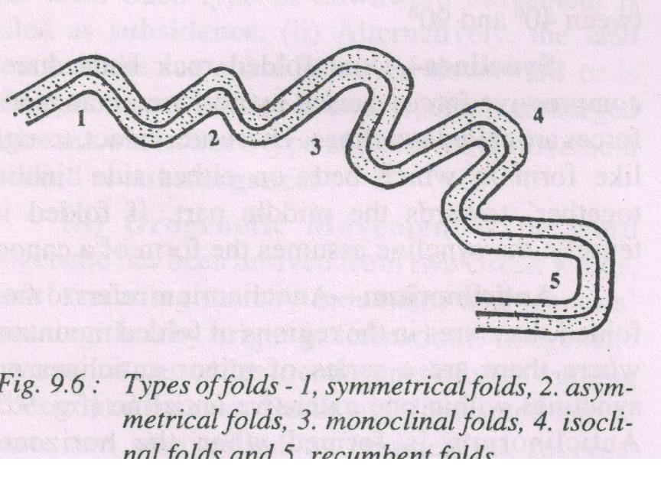
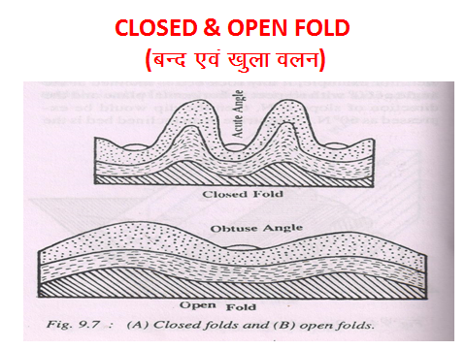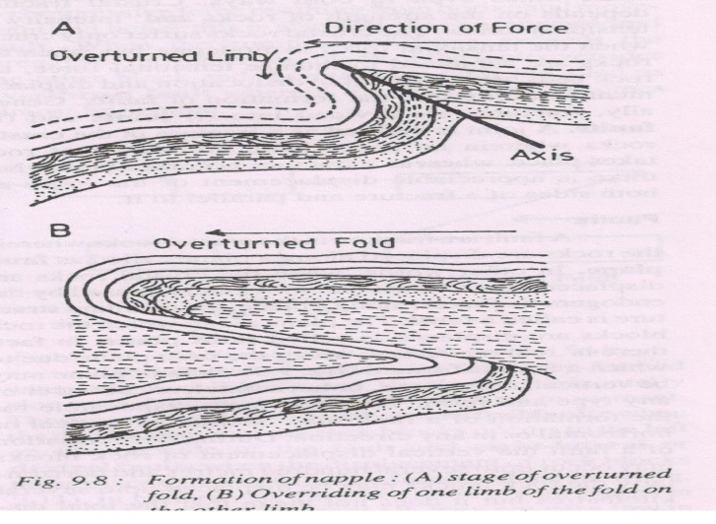
- Open Fold ([kqyk oyu)–
- The fold in which the angle between the two limbs of the fold is more than 90⁰ but less than 180⁰ (obtuse angle between the limbs of the fold. Moderate nature of compressive force make open fold.
- Closed Fold (cUn oyu)–
- Closed fold are those in which the angle between the two limbs of a fold as acute angle (<90⁰). Such folds are formed because of intense compressive force.
- Nappes are the result of comples folding mechanism caused by intense horizontal movement and resultant compressive force.
- When the compressive force becomes so acute that it crosses the limit of the elasticity of the rock bed, the limbs of the fold are so acutely folded that these break at the axis of the fold and the lower rock beds come upward.

------------------------------------------------------000000---------------------------------------------------------------------

